

SYMBIOSIS INTERNATIONAL (DEEMED UNIVERSITY)
(Established under section 3 of the UGC Act 1956)
Re-accredited by NAAC with “A” Grade

Name of the Student: Sneha Sah PRN: 25070122189
Semester: 3 Year: AY 25-29

ASSIGNMENT No: 1

TITLE: Develop an application based on Java environment setup, JDK/JRE/JVM, variables, methods and constructors. and demonstrate the implementation of the concepts through suitable examples.

Problem Statement: Develop an application based on Java environment setup, JDK/JRE/JVM, variables, methods and constructors. and demonstrate the implementation of the concepts through suitable examples.
Exercise:

1. Explain the main concept used in Java environment setup, variables and methods.
- Java Environment Setup: It involves installing the JDK (Java Development Kit), setting the PATH variable, writing the program in a .java file, compiling it using javac, and running it using the java command.
- Variables: Variables are used to store data such as numbers, text, or decimal values. Examples: int, double, char, String.
- Methods: Methods are blocks of code that perform a specific task. They help organise the program and avoid writing the same code repeatedly.

2. What are the advantages of using Java variables and methods?
- Variables make it easy to store and manage data.
- Methods reduce code repetition by allowing code reuse.
- Programs become easier to read and understand.
- Methods make debugging and maintenance simpler.
- They improve the overall structure and efficiency of the program.

3. How can this implementation be improved?
- Use meaningful variable and method names.
- Add comments to explain the code.
- Handle invalid user input using exception handling.
- Divide large programs into multiple methods for better organisation.
- Follow proper coding standards and formatting.

4. What are the real-world applications?
- Student Management Systems
- Banking and ATM applications
- Hospital Management Systems
- E-commerce and shopping websites
- Employee Payroll Systems
- Mobile and desktop applications
- Online reservation and booking systems
- Library Management Systems

Source code:
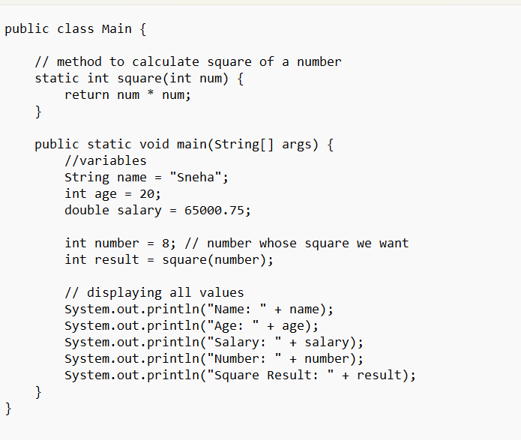
Output:
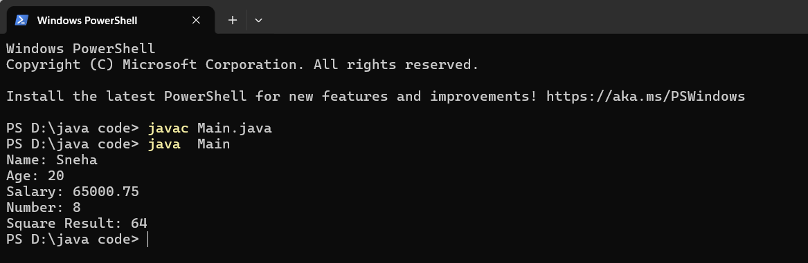

Conclusion:

This assignment helped in understanding the basic concepts of Java programming. We learned how the Java environment works using JDK, JRE, and JVM, and how Java programs are compiled and executed. The implementation of variables, methods, and constructors showed how data is stored, processed, and used to create objects in a program. By developing a simple Java application, we gained practical knowledge of Java syntax, object-oriented programming concepts, and program execution. Overall, this assignment strengthened our foundation in Java and prepared us for learning advanced Java programming concepts.

